# Install Database

B1 : Open project to Visual studio...

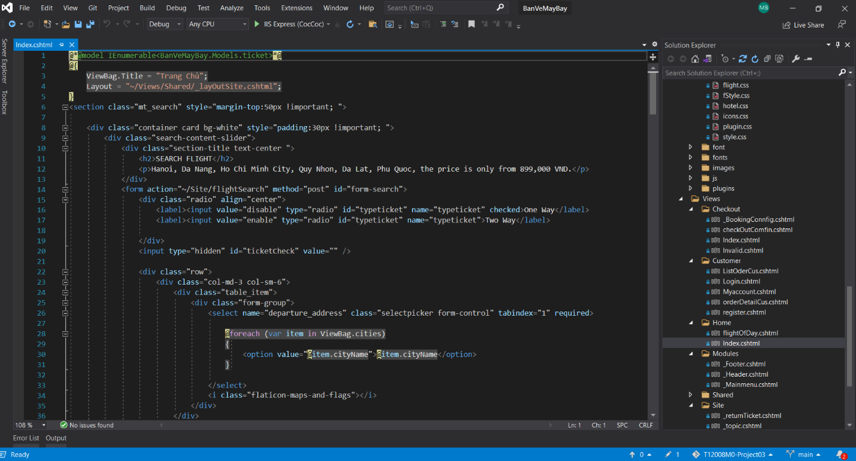

B2 : Connect sql server

(Change connect database with code first or with connection type you know)

* Clik right button Database -> Import Data-tier Application

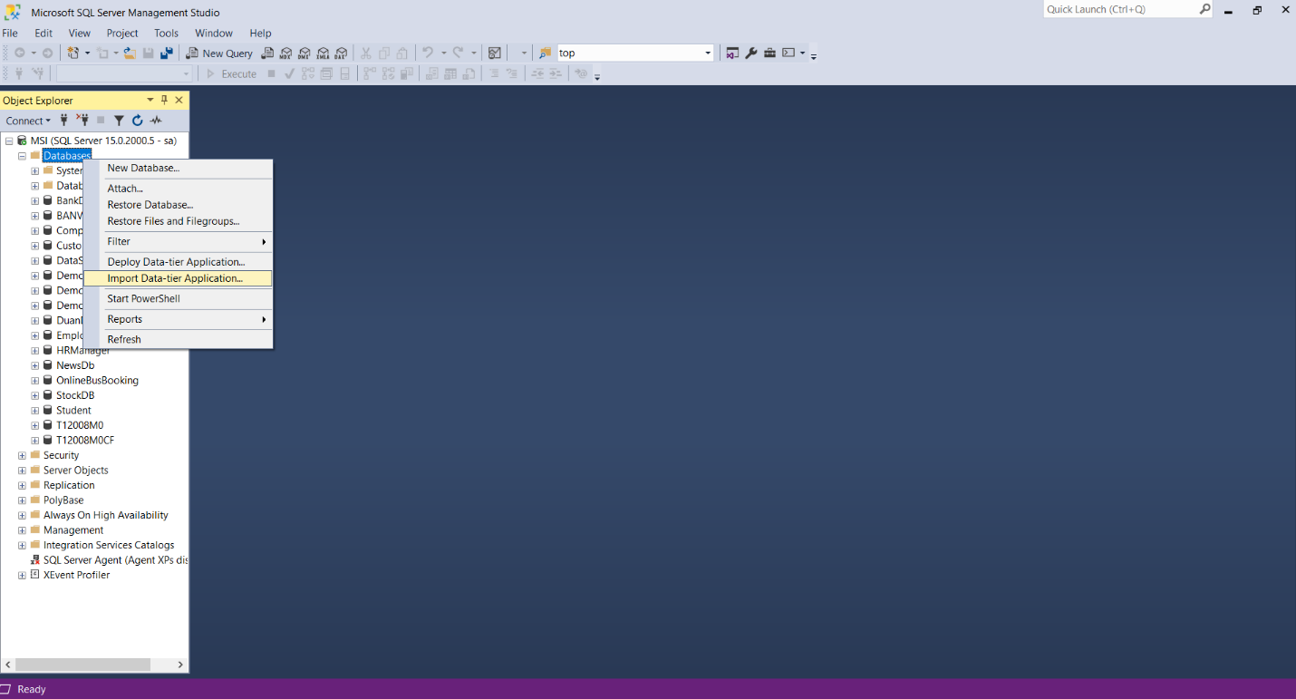

* Clik Browse button -> link to BANVEMAYBAY.bacpac(in DOC)

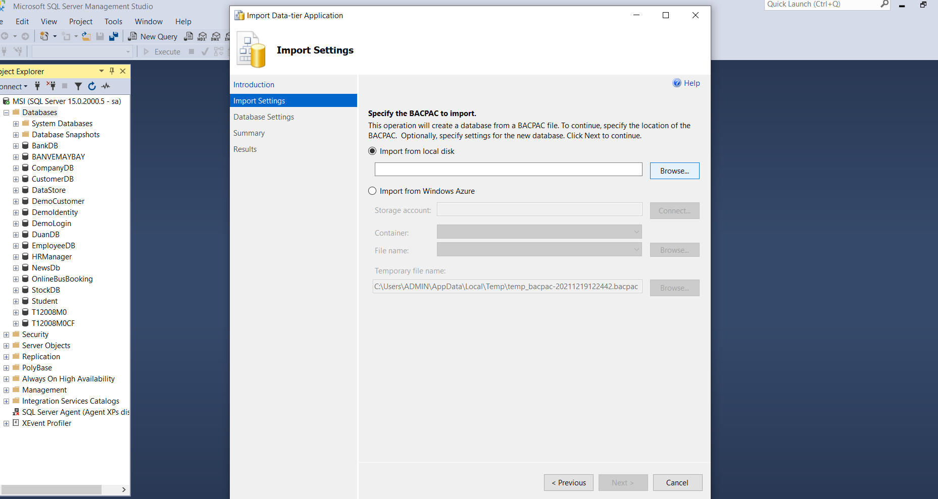

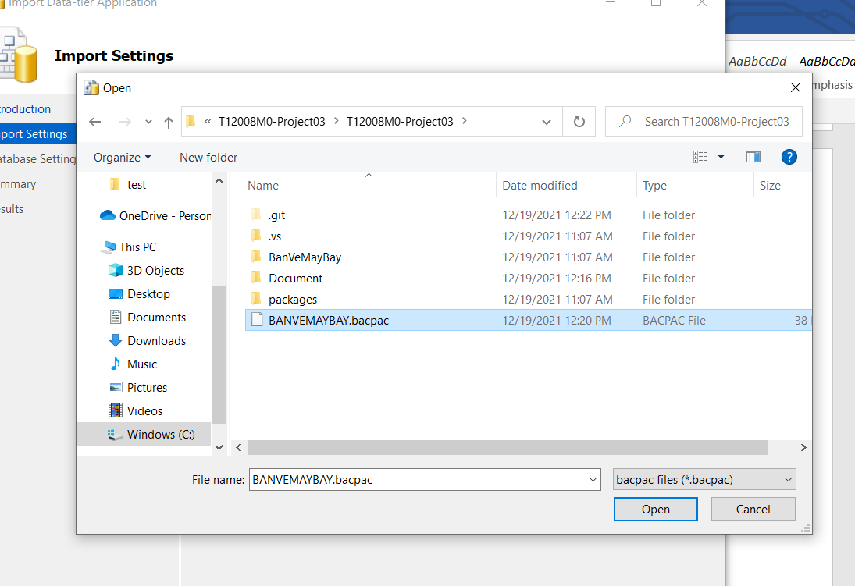

B3 : run the project

username/password (can be placed in dbo.user)

Installation support is available

Note: The report file and source code are compressed into the main file